**INSTITUTE OF AERONAUTICAL ENGINEERING**

**DUNDIGAL, HYDERABAD**



**TWO WEEKS SUMMER INTERNSHIP**

**ON**

**FOOD WEBSITE(WEB APPLICATION)**

**BY**

**GURRAM ANKIT**

**20951A0415**

**ECE**

**UNDER THE GUIDENCE**

**OF**

**Dr. G RAMU**

|  |  |
| --- | --- |
| **S.NO** | **CONTEXT** |
| 1 | Title |
| 2 | Abstract:  Brief introduction  Existing System  Proposed System |
| 3 | Introduction |
| 4 | Literature Survey |
| 5 | Proposed System |
| 6 | Conclusion |

**ABSTRACT:**

In this project, PHP and SQL technologies will be used to create a cuisine website. The website seeks to provide consumers a simple platform where they can register, explore the menu, order meals, and select payment methods. Users will also be able to create support or inquiry tickets. For the purpose of managing menu items, orders, tickets, and transactions, an administrator panel will be put in place. The website will also include a landing page specifically for food donations where users can enter their information to make a gift. Once the gift has been completed, the information will be retained just briefly before being destroyed. To secure user data and sensitive information, security measures will be applied across the website. The website will improve user experience by providing order tracking capabilities that allows users to keep track of the status of their orders. The overall goal of this project is to develop a functional and practical food website that offers a wide range of capabilities for both users and administrators.

**Brief Introduction**:

Customers may easily explore and discover their favorite dishes on our website thanks to its user-friendly design. Users may enjoy a flawless ordering process without worrying about cash transactions thanks to our easy card payment option. The administrator portal guarantees effective control of the website's data, orders, and other elements. Additionally, the food donation website demonstrates our dedication to social responsibility. By donating meals, people can combat food insecurity and aid those in need while also giving back to their community.

Our food website provides a complete online meal ordering solution, safe card payments, administrative administration, and a special function for food donations. We work to give people access to a practical and ethical platform.

**Existing system:**

It's vital to keep in mind that precise use data and statistics for various technologies may differ, and their implementation would rely on the particular needs and preferences of the food website. Additionally, the development process and user experience may be improved further by technological developments and the availability of additional frameworks and tools.

Certainly! Here is a list of some well-known rivals in the food ordering and delivery sector.

**Uber Eats:** A major participant in the meal delivery industry, Uber Eats offers a vast variety of cuisines from different restaurants.

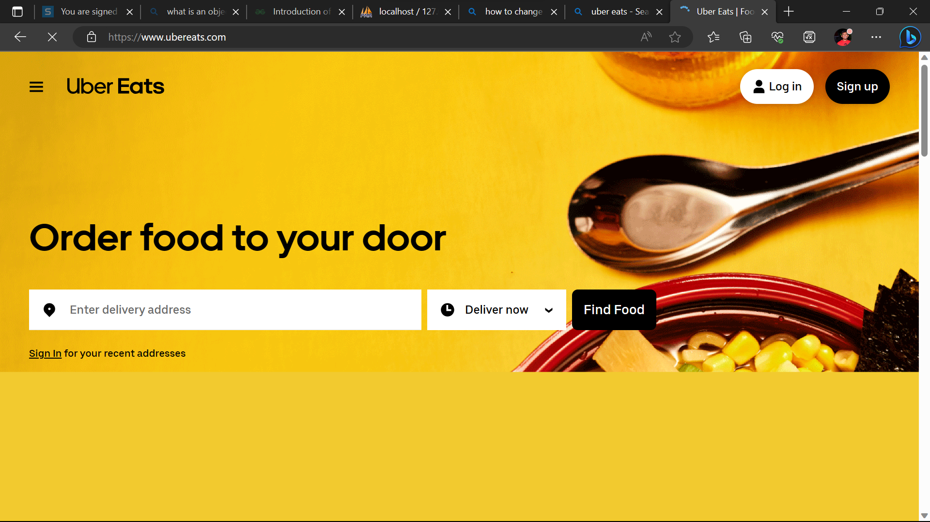

**Door Dash**: Door Dash is a food delivery business that collaborates with neighborhood eateries to provide clients on-demand delivery services.

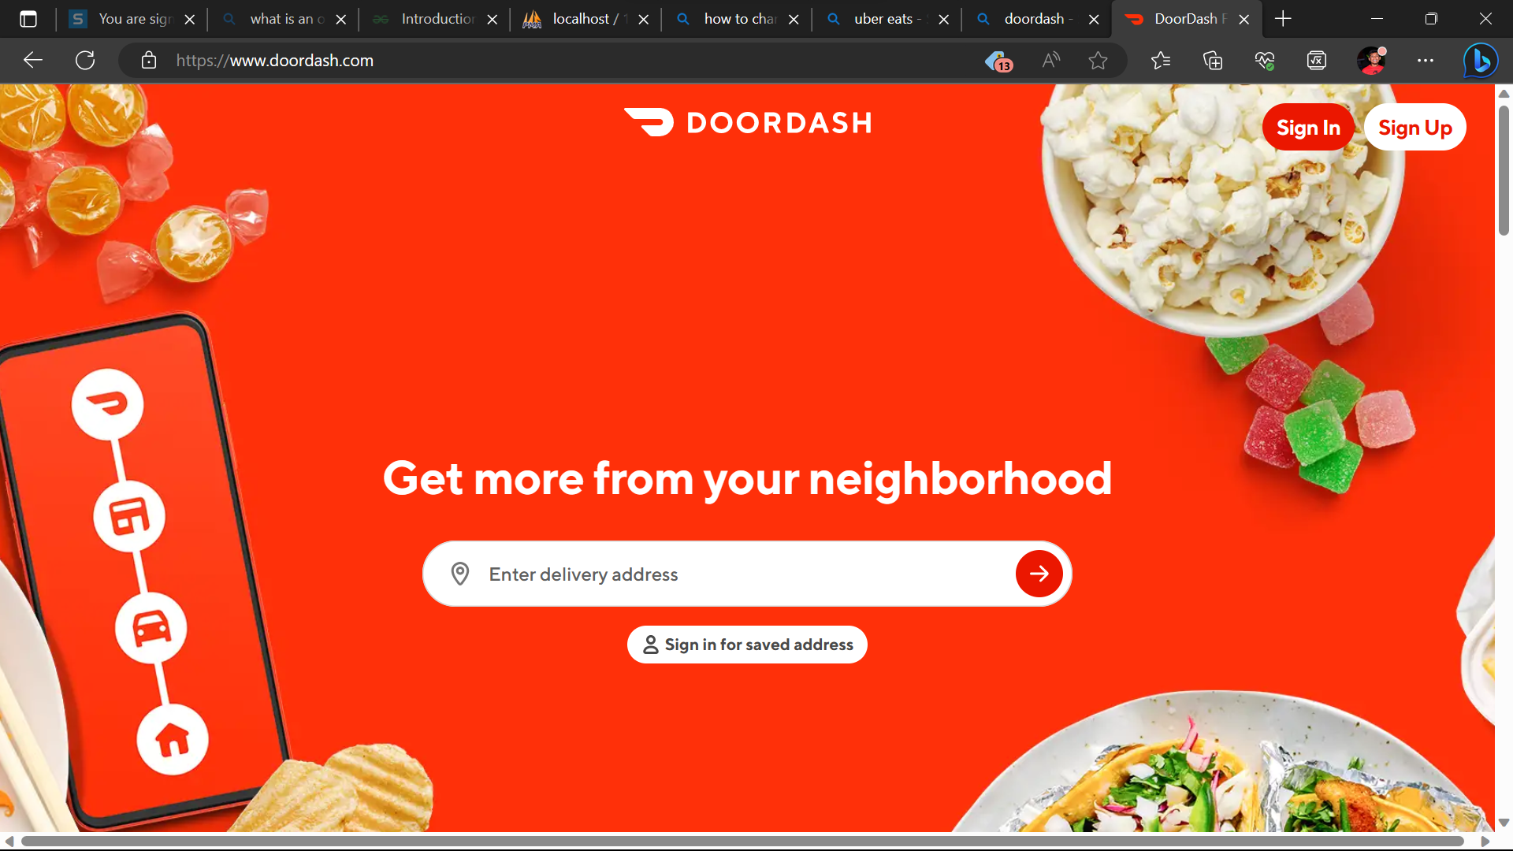

**Grubhub:** Grubhub is a well-known online food ordering and delivery service that links customers with nearby eateries.

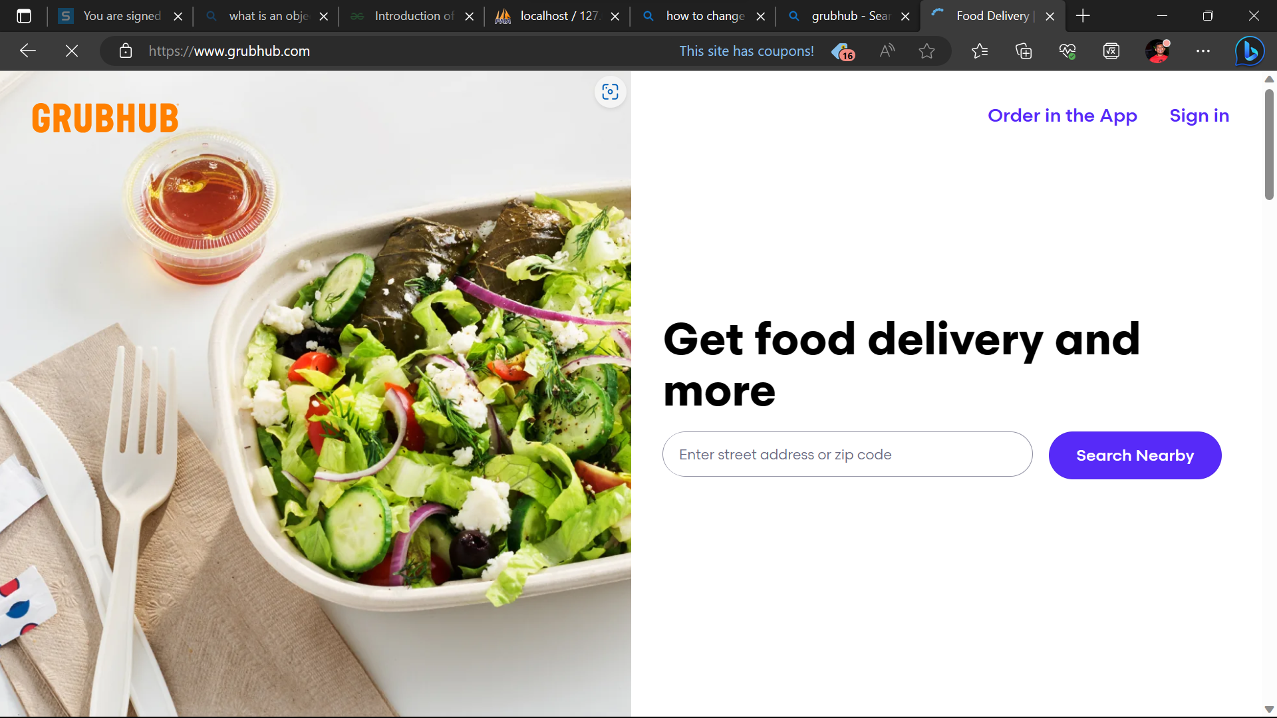

**Postmates:** Postmates is a delivery service that delivers a variety of products, including groceries and home goods, in addition to food delivery.

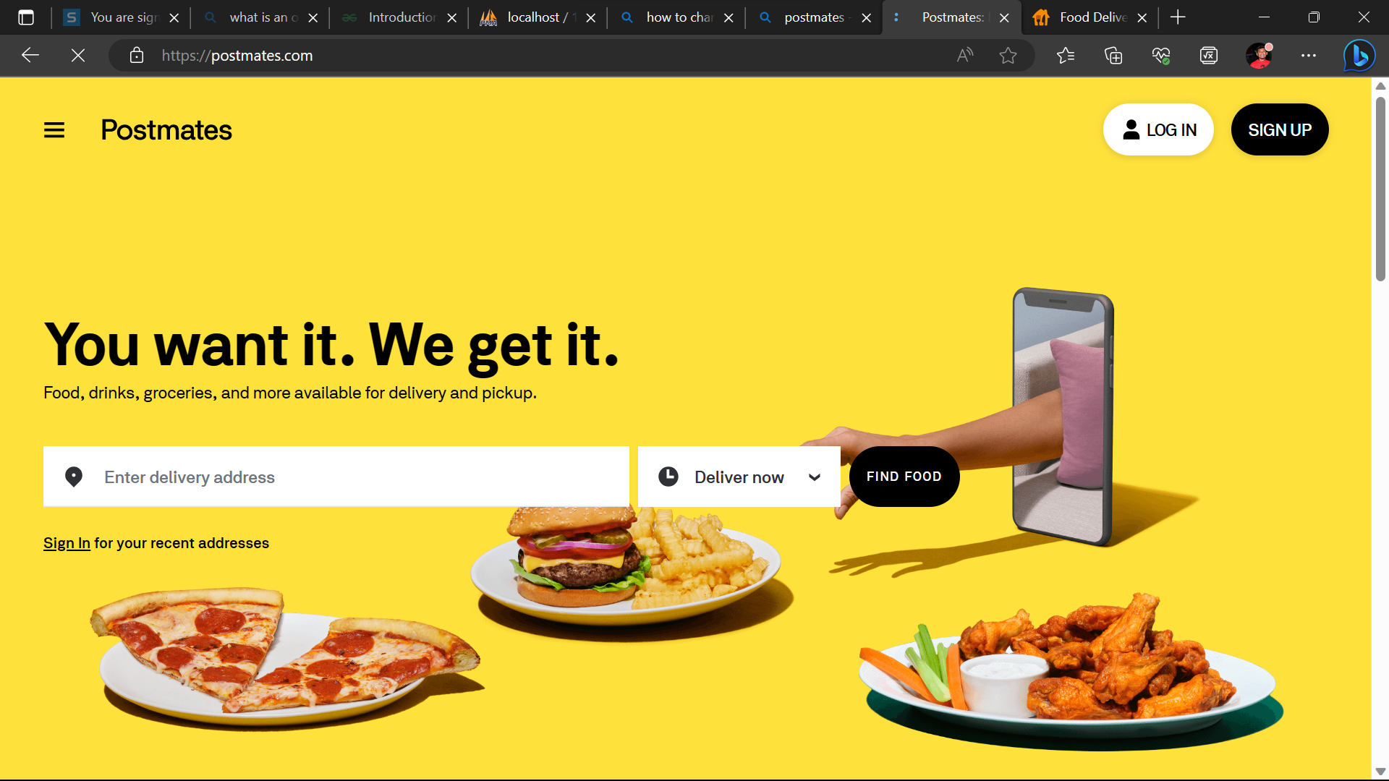

**Deliveroo:** Operating in numerous nations, Deliveroo is a food delivery platform that provides a wide range of restaurant alternatives and delivery services.

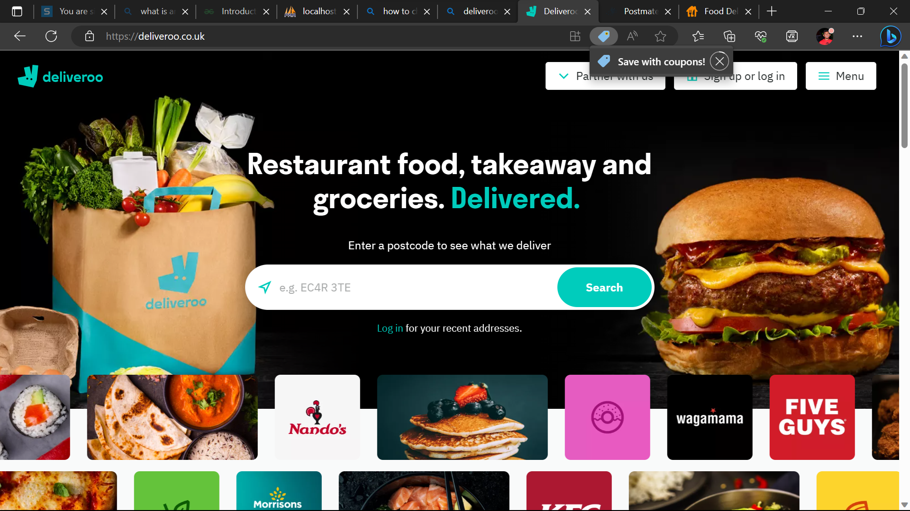

**Zomato**: Users may access a huge variety of restaurants thanks to Zomato, a well-known food delivery and restaurant discovery network that works internationally.

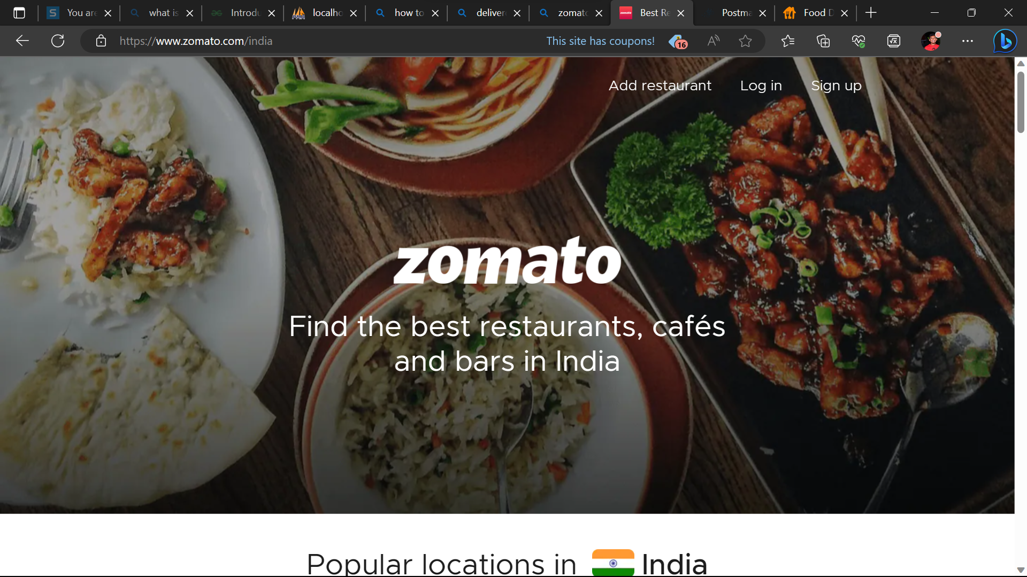

**Swiggy:** A popular food ordering and delivery service in India, Swiggy is renowned for its broad restaurant network and quick delivery options.

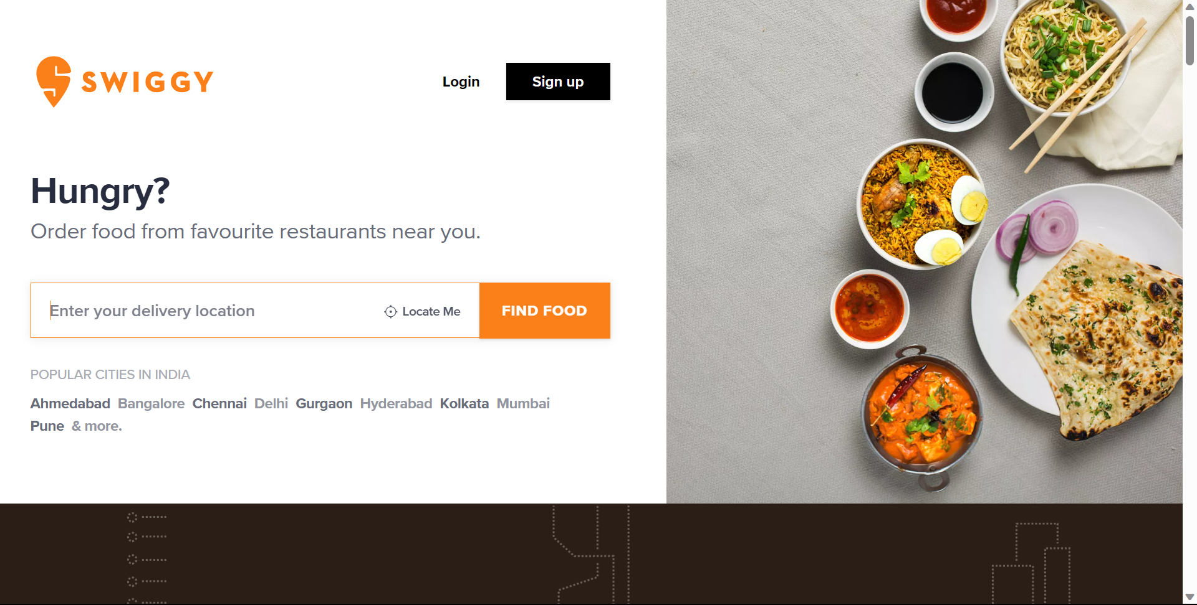

**Foodpanda**: This international network for food delivery online connects customers with nearby eateries for simple ordering and delivery.

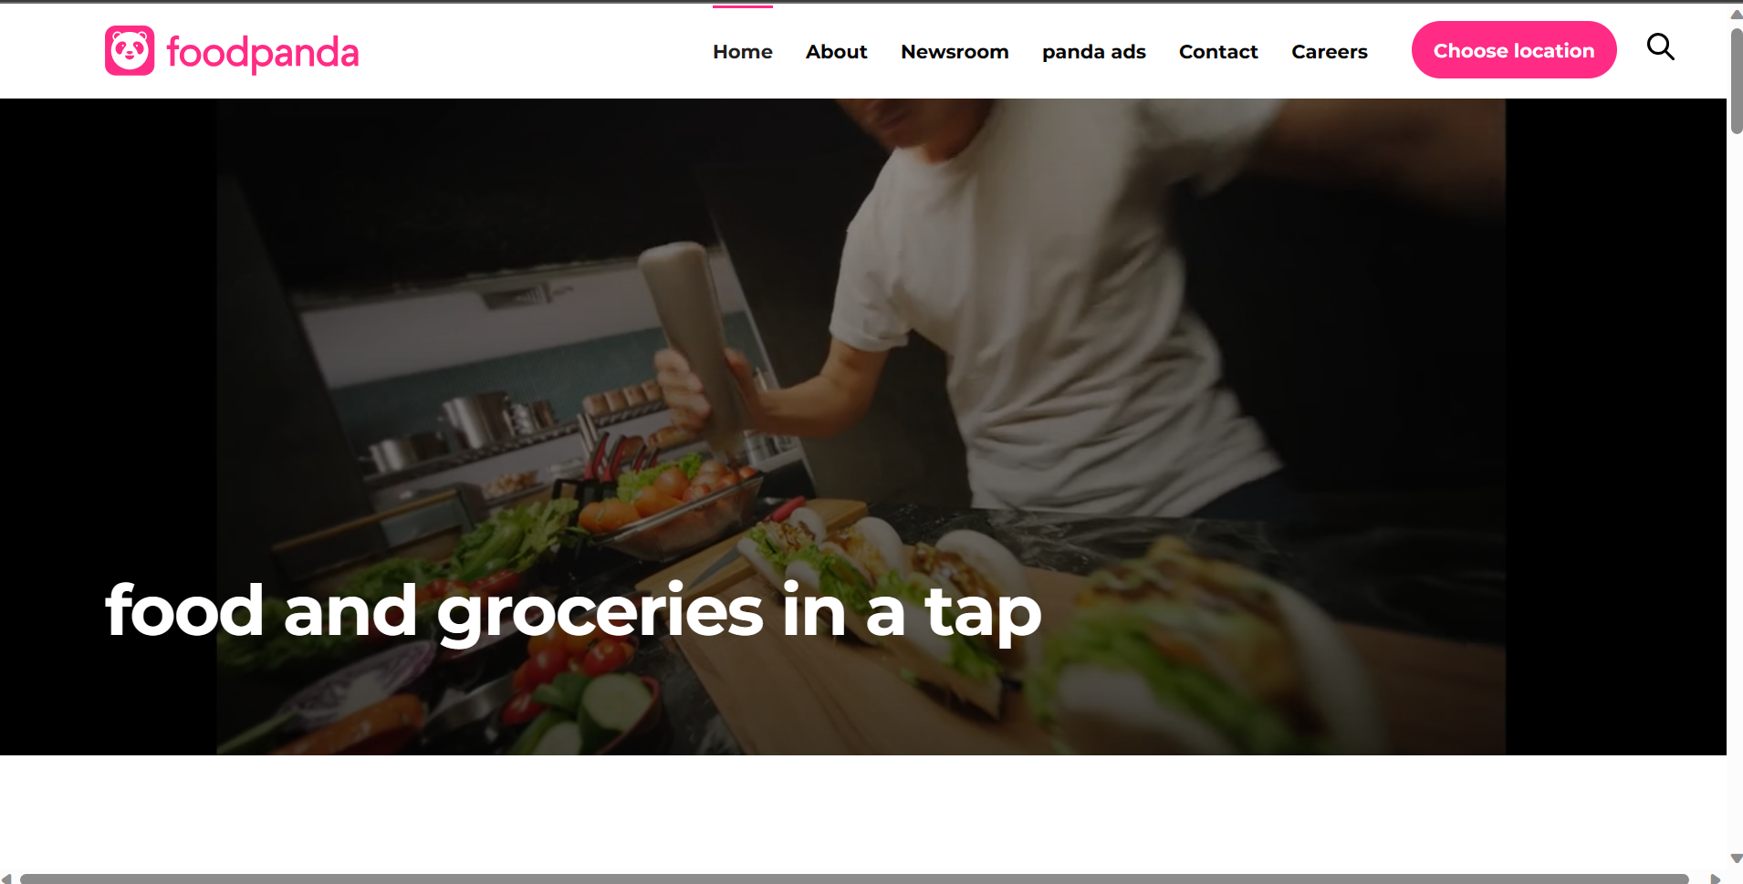

**Proposed system:** The suggested system is a food website that was created with PHP for the front-end and SQL for the database management. In addition to giving administrative tools for managing menu items, orders, tickets, and transactions, it intends to give users with a user-friendly platform on which to place food orders.

**The system includes the following features:**

**User Registration:** Users can create accounts by providing their name, email, and password. The system ensures secure password storage through hashing techniques.

**Menu Display:** The website showcases a menu with various food items. The menu items and their details are stored in a database table, allowing users to browse and select items easily.

**Ordering System**: Users can add food items to a cart or order list. Once the order is finalized, it is stored in a database table, including details such as the items ordered, quantity, and customer information.

**Payment Options:** The system integrates a payment gateway API (e.g., Stripe, PayPal, or Braintree) to enable online payments. Users can select their preferred payment method during checkout.

**Ticketing System:** Users can raise tickets or submit inquiries through a form. These tickets are stored in a database table with unique ticket IDs. Administrators can view and respond to these tickets.

**Order Status and Tracking:** The system tracks the status of orders, allowing users to check the progress of their orders. Order status is stored in the database and updated as the order is processed.

**Administrator Panel:** Administrators have access to an administrative dashboard where they can manage menu items, view and update orders, respond to tickets, and monitor transactions.

**Food Donations:** The website includes a separate landing page for food donations. Users can fill out a form with their donation details, which are temporarily stored in a database table. The information can be deleted once the donation is processed.

The proposed system emphasizes security measures to protect user data, secure authentication, and encryption of sensitive information. It aims to provide a comprehensive and user-friendly experience for both users and administrators, facilitating smooth food ordering, payment processing, and customer support.

**INTRODUCTION**

The food website project is focused on creating a dynamic and user-friendly online platform for ordering food. The website will be developed using PHP for the front-end and SQL for managing the database. The primary goal of the website is to provide a seamless experience for users to register, explore the menu, place food orders, and select their preferred payment method, including options for card payment or cash on delivery. Users will also have the ability to raise tickets for any inquiries or support they may require.

To ensure efficient management of the website, an administrator panel will be implemented. The administrator will have access to edit the menu, track and manage orders, update order status, and monitor transactions. This allows for effective monitoring and control of the website's operations.

An additional feature of the website is a dedicated landing page for food donations. This page will enable individuals to contribute food donations by providing their details through a form. Once the donation is processed, the information will be securely stored temporarily and can be promptly deleted.

Throughout the development process, security measures will be implemented to safeguard user data and sensitive information. This includes implementing secure password storage, protecting against SQL injections, and ensuring secure transmission of payment data.

To enhance user satisfaction, the website will provide order tracking functionality. Users will have the ability to check the status of their orders, allowing them to stay informed about the progress and estimated delivery time.

Overall, the food website project aims to deliver a comprehensive and user-friendly online platform for food ordering, incorporating features such as user registration, menu browsing, ordering, payment options, ticketing system, order tracking, and an administrator panel. The project prioritizes security and user convenience to ensure a seamless and enjoyable experience for both users and administrators.

**LITERATURE SURVEY**

A literature survey for a food web application:

**1.Food Delivery and Ordering Systems**: Explore academic papers and industry reports that discuss the design, development, and challenges associated with food delivery and ordering systems. Look for studies on user experience, order management, payment processing, and logistics optimization.

**2.User Interaction and Interface Design**: Investigate research on user interaction and interface design for food ordering websites. This may include studies on usability, user experience (UX) design, and user interface (UI) design principles specifically relevant to food delivery platforms.

**3.Payment Processing and Security:** Look for literature related to online payment processing and security measures specific to food web applications. Topics may include payment gateway integration, encryption techniques, fraud prevention, and customer trust factors.

**4.Mobile Application Development:** If your food web application includes a mobile component, explore research on mobile application development, including technologies, frameworks, and best practices for creating efficient and user-friendly mobile apps.

**5.Personalization and Recommendation Systems:** Investigate literature on personalized recommendations and recommendation systems in the food delivery domain. This may involve studying techniques for analyzing user preferences, collaborative filtering, and content-based recommendations.

**6.Food Donation Platforms**: If you are focusing on the food donation feature, explore literature on food donation platforms, food waste management, and initiatives that connect donors with those in need.

**7.Operational Efficiency and Logistics:** Look for research that addresses operational efficiency and logistics optimization in food delivery systems. This may include studies on route optimization, delivery time prediction, and demand forecasting.

When conducting a literature survey, it's essential to search through academic databases, industry publications, conference proceedings, and related research papers. Additionally, you may consider reaching out to experts or professionals in the field of food delivery, web development, or related areas for their insights and recommendations.

**PROPOSED SYSTEM**

Our website, Food website, stands out from other food delivery and ordering websites due to its distinct features and offerings. Here are some ways in which Food website differentiates itself:

**Food Donation Page:** Food website's special feature of a dedicated food donation page sets it apart. This platform allows users to contribute meals to those in need, providing an opportunity for users to make a positive impact on the community.

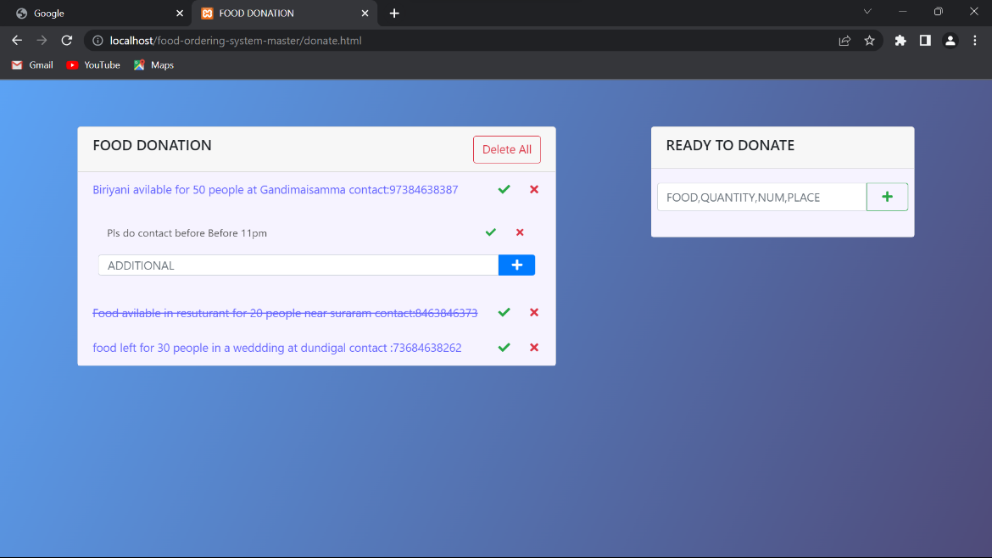

**Administrator Access and Data Editing:** Food website grants the administrator full access to edit and manage all data, including restaurant listings, menus, and customer information. This feature enables efficient administration and ensures up-to-date and accurate information.

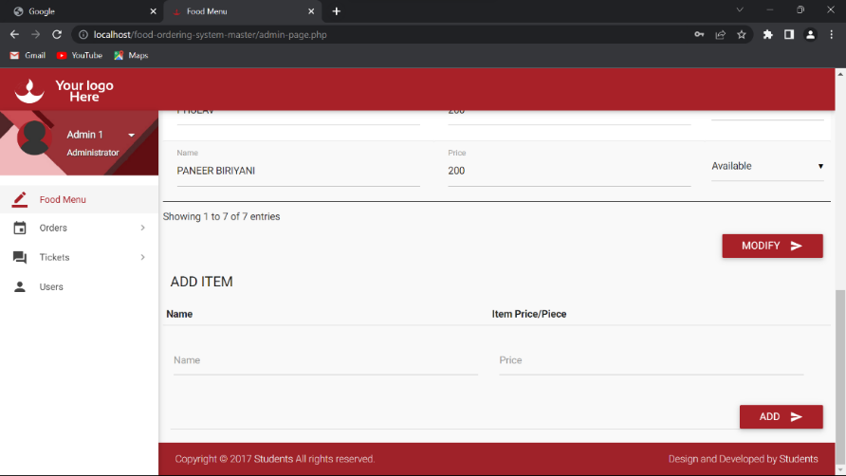

**User Registration:** Users can create accounts by providing their name, email, and password. The system ensures secure password storage through hashing techniques.

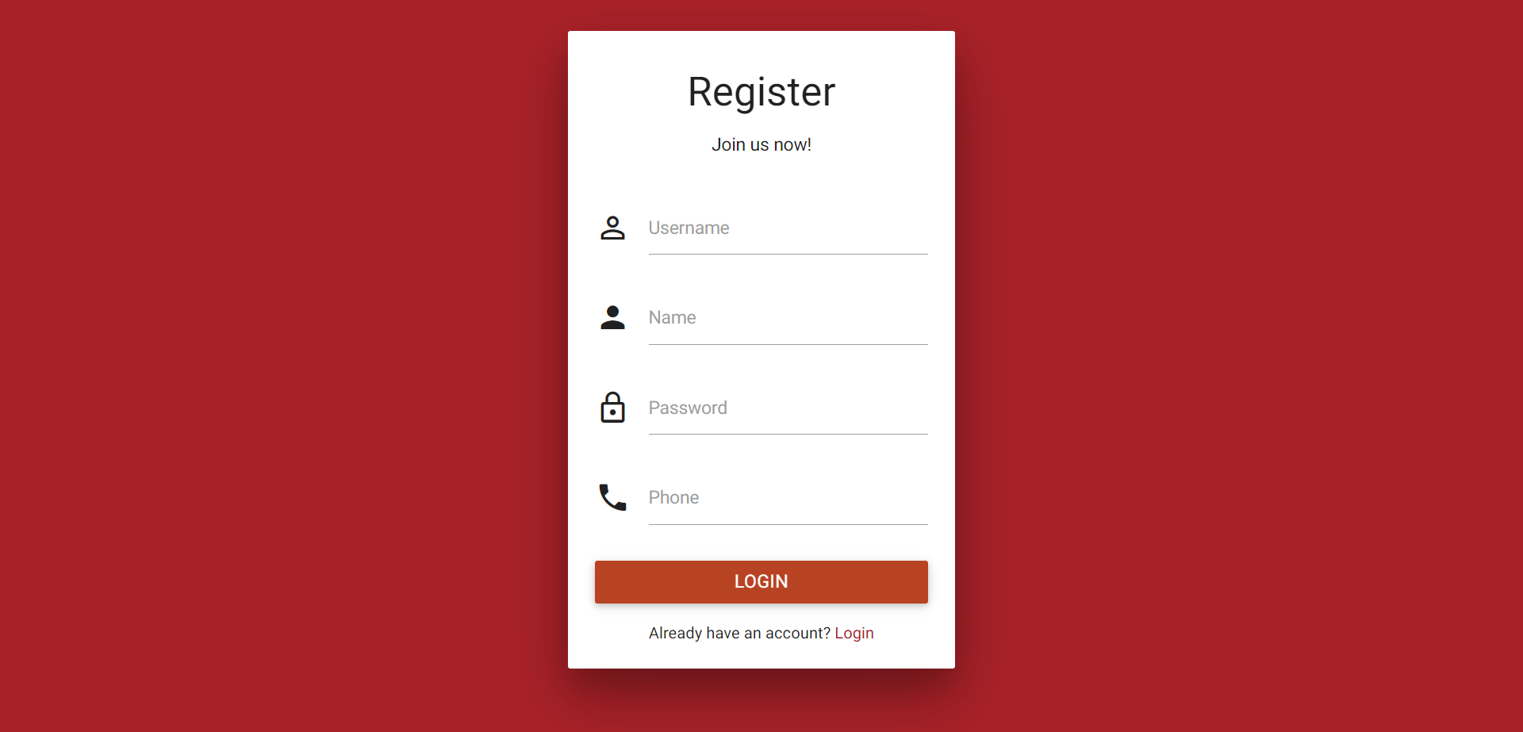

**Menu Display:** The website showcases a menu with various food items. The menu items and their details are stored in a database table, allowing users to browse and select items easily.

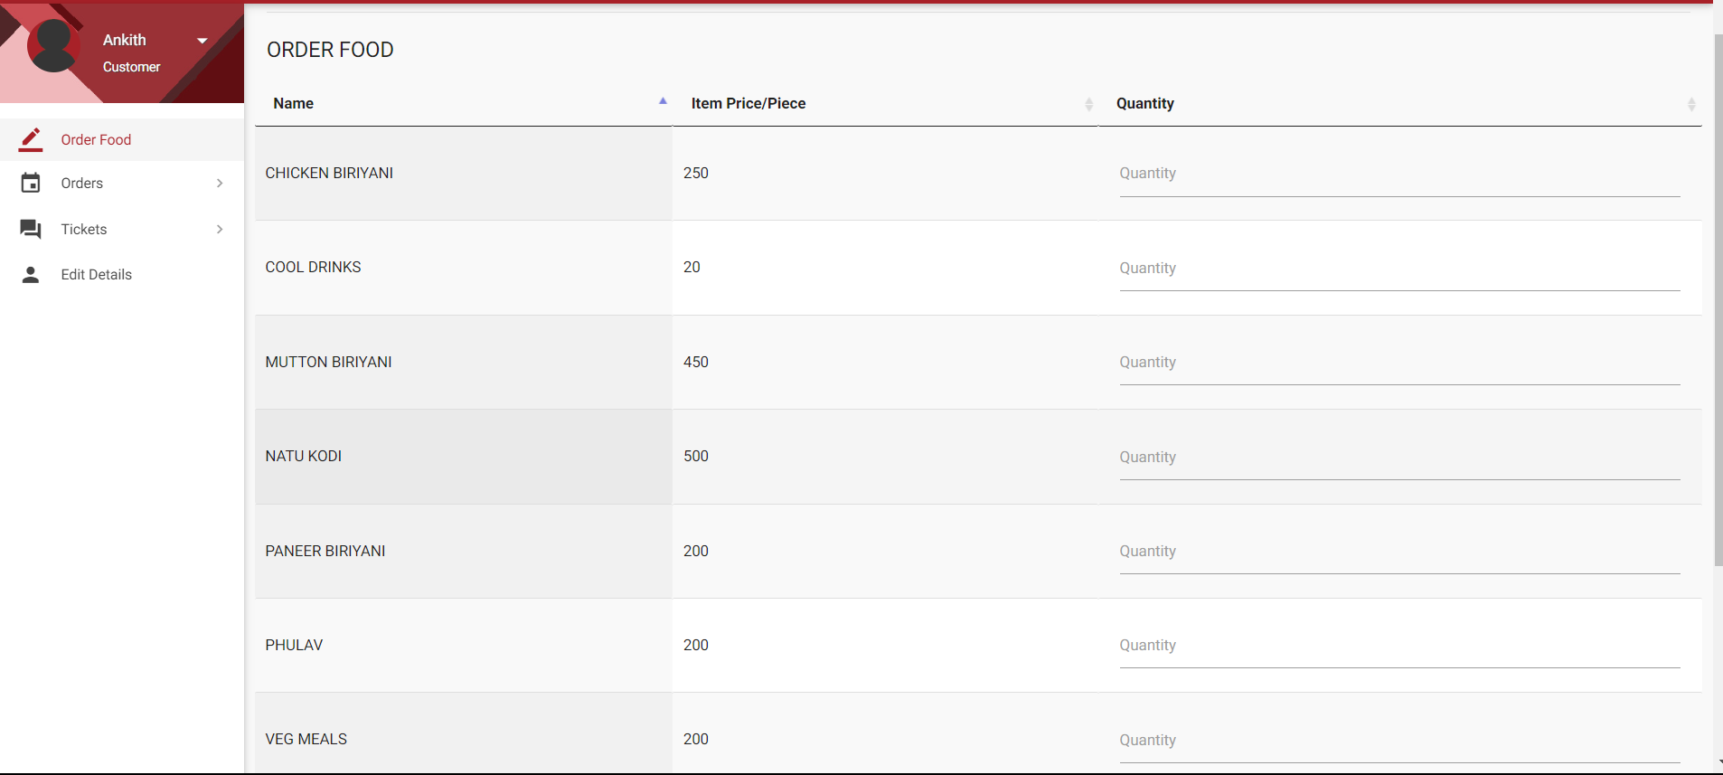

**Emphasis on User Profile Management**: Customers can easily update their personal information, delivery addresses, and payment details through the "Edit Details" option. This ensures accuracy and convenience when placing orders.

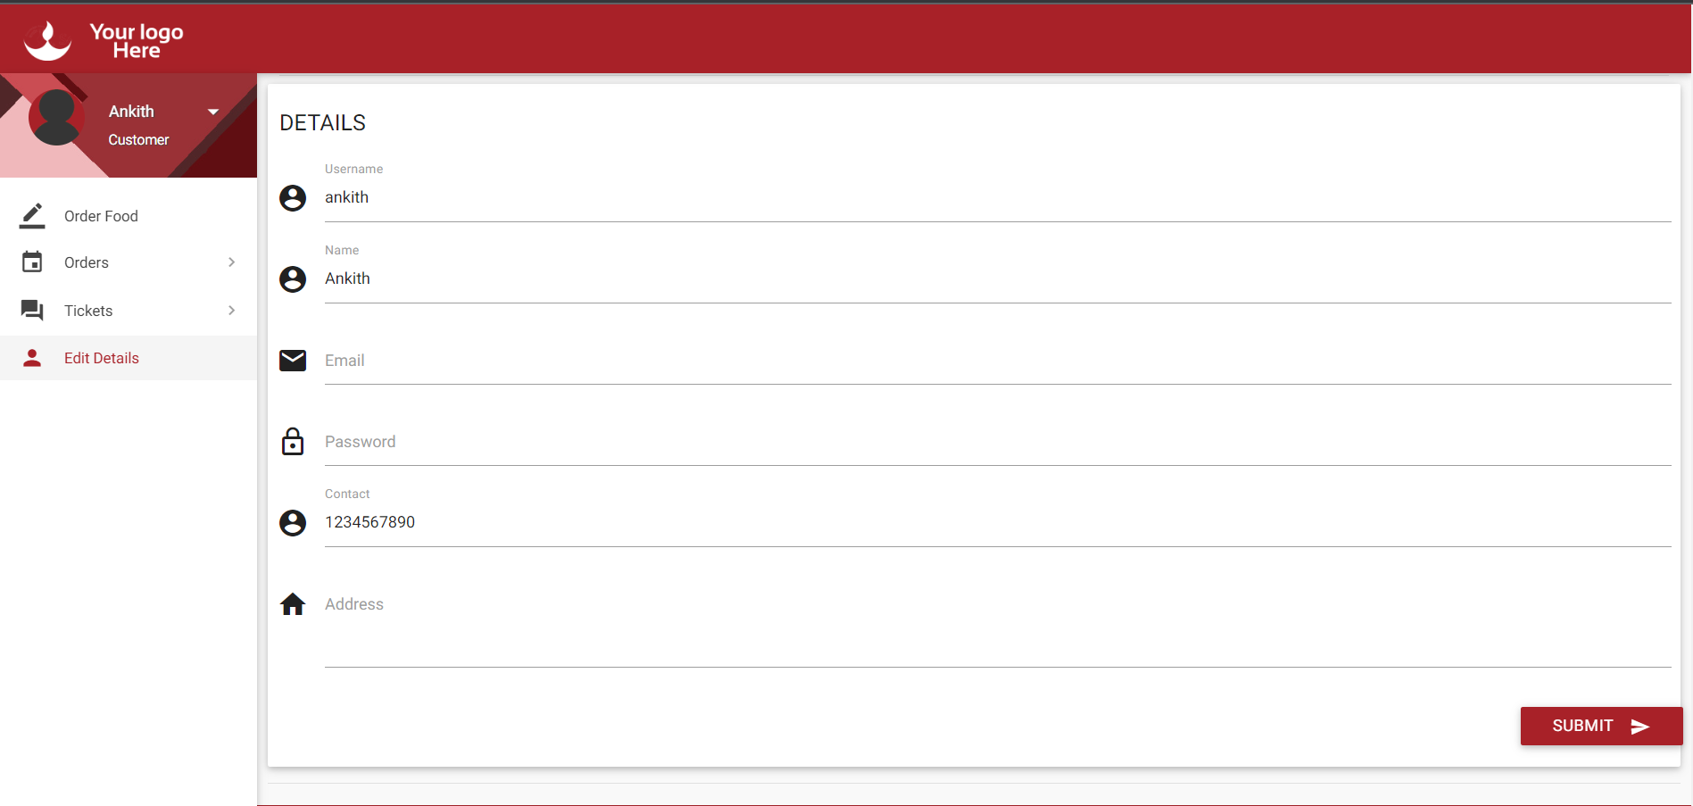

**Ticketing System:** Food website's ticket-raising option for customers allows them to submit queries, feedback, or concerns. This feature demonstrates a commitment to customer support and ensures that customer inquiries are promptly addressed.

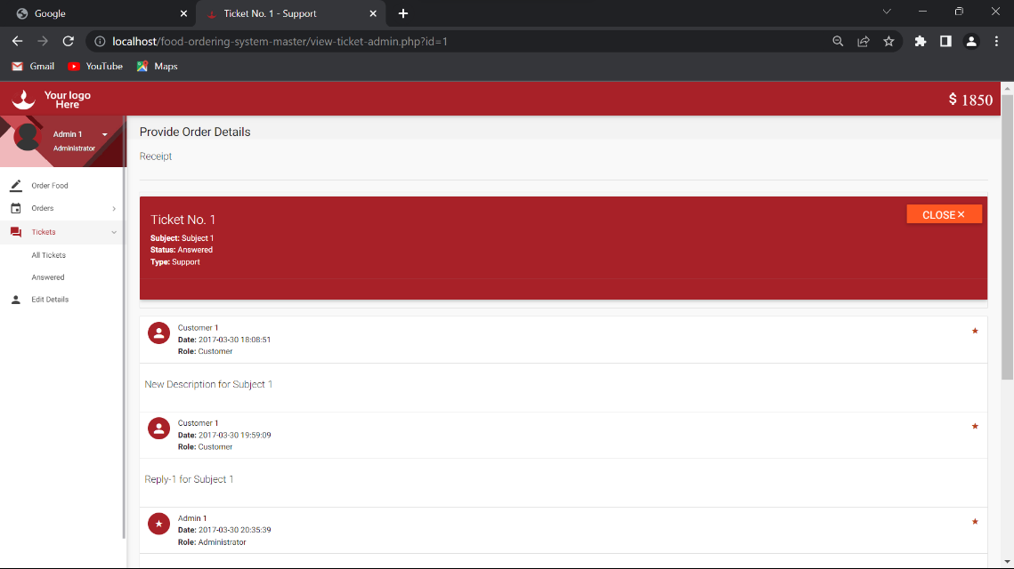

**Wallet Option**: Food website provides a wallet feature where users can add funds to their accounts. This allows for faster and more convenient transactions and adds a level of flexibility to the payment process.

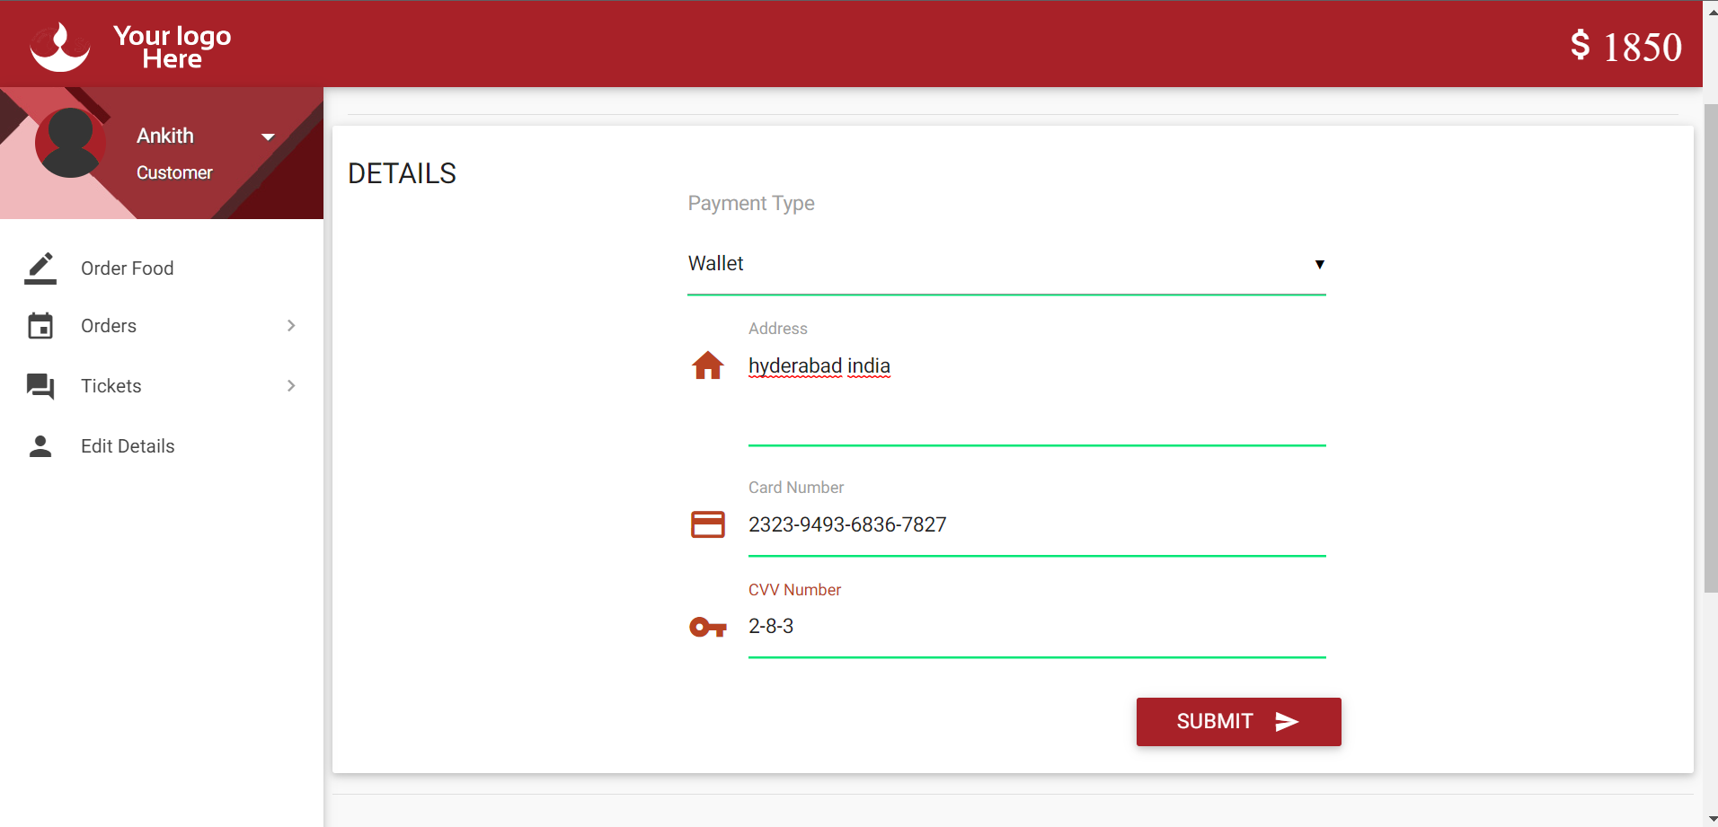

**Cash on Delivery and Card Payment Options**: Food website offers customers both cash on delivery and card payment options. This versatility accommodates various customer preferences and enhances the overall user experience.



**Order Status and Tracking:** The system tracks the status of orders, allowing users to check the progress of their orders. Order status is stored in the database and updated as the order is processed.

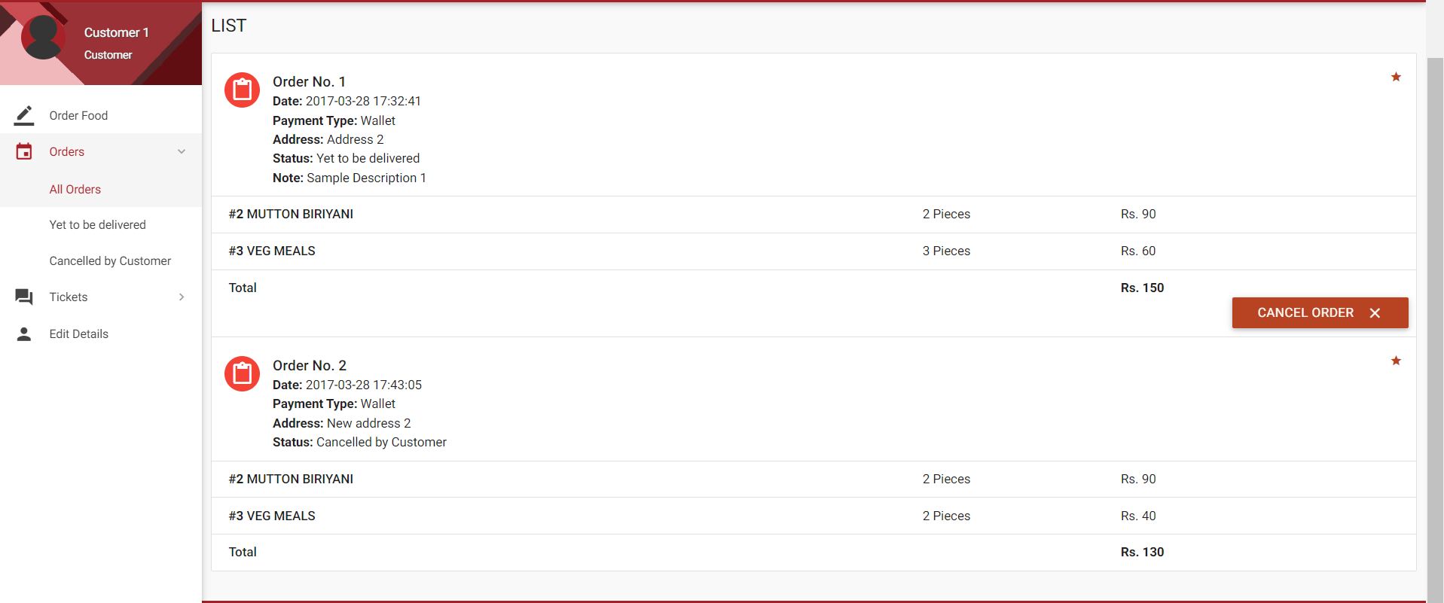

**BACKEND**

Backend development refers to the implementation of server-side logic and functionality that powers a website, web application, or software system. It involves handling data storage, processing user requests, and generating dynamic content to be delivered to the client-side (front-end) of the application.

The backend is responsible for managing the server, databases, and business logic that drive the application's functionality. It primarily focuses on handling data storage, retrieval, and manipulation, as well as performing complex calculations or operations.

There are totally 8 tables in the project:

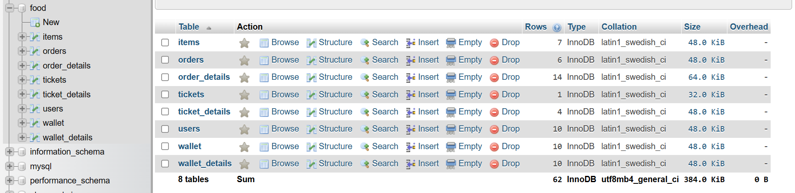

**Items Table:**

This table contains information about the available food items in the menu.

It will include columns such as:

* Item ID (unique identifier for each item)
* Item Name (name or title of the item)
* Description (brief description of the item)
* Price (the cost of the item)
* Availability (indicator of whether the item is currently available)
* Additional details specific to your project requirements.

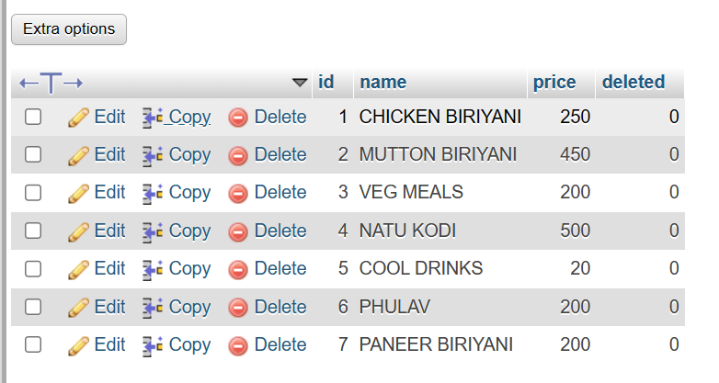

**Orders Table:**

This table stores information related to customer orders.

It will include columns such as:

* Order ID (unique identifier for each order)
* Customer ID (reference to the customer placing the order)
* Order Date (timestamp indicating when the order was placed)
* Total Amount (the total cost of the order)
* Status (current status of the order, e.g., pending, delivered)
* Payment Method (method of payment used for the order)
* Delivery Address (address where the order should be delivered)

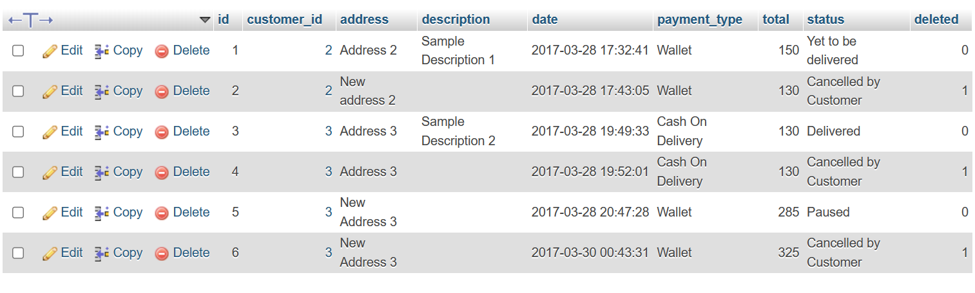

**Customers Table:**

This table stores customer details who register on the website.

It will include columns such as:

* Customer ID (unique identifier for each customer)
* Name (customer's full name)
* Email (customer's email address)
* Password (hashed password for customer account security)
* Address (customer's residential or contact address)
* Phone Number (customer's contact number)

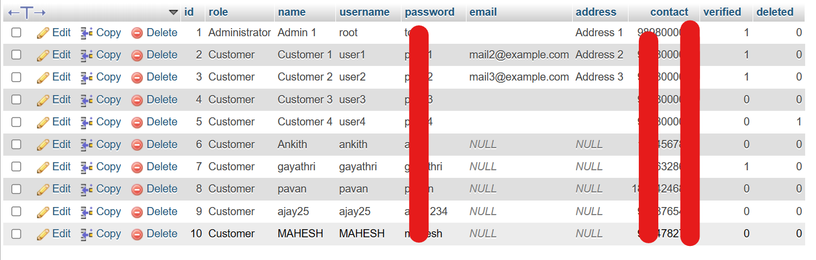

**CONCLUSION**

In conclusion, conducting a literature survey for a food web application involves exploring various research papers, industry reports, and related sources to gather information on key aspects of food delivery and ordering systems. Some important areas to focus on include user interaction and interface design, payment processing and security, mobile application development (if applicable), personalization and recommendation systems, food donation platforms, and operational efficiency and logistics optimization.

By delving into the existing literature, you can gain valuable insights into user experience, best practices in design and development, payment processing methods, security measures, mobile app development frameworks, personalized recommendations, food waste management, and logistics optimization in the food delivery domain. The literature survey helps you understand the current state of the field, identify potential challenges, and gather ideas and strategies to enhance your food web application.

Remember to explore academic databases, industry publications, conference proceedings, and seek expert opinions to ensure a comprehensive literature survey. This research will provide you with a solid foundation of knowledge to inform the design, development, and overall success of your food web application.

In conclusion, Food website is an exceptional food ordering website that sets itself apart from its competitors through its unique features and user-centric approach. With a seamless ordering process, secure card payment option, and convenient cash on delivery, Food website prioritizes customer convenience and satisfaction.

The standout feature of Food website is its dedicated food donation page, providing a platform for users to contribute meals to those in need. This emphasis on social responsibility sets Food website apart and allows users to make a positive impact on their communities.

Additionally, Food website offers an administrator access feature, enabling efficient data management and the ability to edit and update restaurant listings, menus, and customer information. This ensures accuracy and up-to-date information on the platform.

The ticketing system in Food website enables customers to raise queries, provide feedback, or seek support, with the assurance of timely resolution from the dedicated support team. This commitment to customer support enhances the overall user experience.

The wallet option allows users to add funds to their accounts, facilitating faster and more convenient transactions. Alongside this, the user profile editing feature empowers customers to update their personal information, delivery addresses, and payment details, ensuring flexibility and accuracy in their orders.

Food website stands out as a comprehensive and user-friendly food ordering website, combining convenience, security, and social impact. By offering a unique set of features, Food website delivers a differentiated experience, making it a top choice for users seeking a reliable and socially conscious food delivery platform.